NEURO TRACK SMART HELMET FOR ACCIDENT DETECTION
& HEALTH MONITORING

NOEL JOYCE VARGHESE
Electronics and Communication
Amal Jyothi College of Engineering
Kottayam, Kerala
noeljoycevarghese2026@ec.ajce.in
SWATHI KRISHNA
Electronics and Communication
Amal Jyothi College of Engineering
Kottayam, Kerala
swathikrishna2026@ec.ajce.in

SHARON THOMAS
Electronics and Communication
Amal Jyothi College of Engineering
Kottayam, Kerala
sharonthomas2026@ec.ajce.in

ROHAN P THOMAS
Electronics and Communication
Amal Jyothi College of Engineering
Kottayam, Kerala
rohanpthomas2026@ec.ajce.in

DR.THERESA YAMUNA MAHESH
Professor
Electronics and Communication
Amal Jyothi College of Engineering
Kottayam, Kerala.
theresayamunamahesh@amaljyothi.ac.in

AGI JOSEPH GEORGE
Asst. Professor
Electronics and Communication
Amal Jyothi College of Engineering
Kottayam, Kerala
ajijosephjosephgeorge@amaljyothi.ac.in

ABSTRACT--The development of this Smart Helmet is driven by the responsibility to improve road safety and emergency response. The lack of immediate medical assistance after accidents significantly increases the risk of fatalities, often due to delayed ambulance arrival or the absence of bystanders to report the incident. To address this issue, our proposed model, “Smart Helmet for Accident Detection and Health Monitoring”, incorporates an automated accident detection system that instantly informs emergency contacts. The system uses an MPU6050 accelerometer to detect crashes, while an alcohol sensor (MQ-3) ensures the rider is not intoxicated before starting the vehicle. In the event of an accident, an IoT-enabled GSM module (SIM800L) sends an SOS alert with real-time GPS location (Neo-6M) to predefined emergency contacts. Additionally, biomedical sensors (EEG, MAX30102) monitor vital signs (brain activity, heart rate, and SpO2) to assess the rider’s post-accident condition could be imparted in to the system. The helmet is powered by a 7.4V 2000mAh rechargeable Li-ion battery with a Battery Management System (BMS) for efficiency. This system enables faster emergency response, real-time health analysis, and improved accident tracking, making it a crucial life-saving innovation.
Keywords-smart helmet, accident detection, MPU6050, GSM, GPS, Alcohol Detection, Road Safety.
- INTRODUCTION
Motorcycle crashes are a major reason to road fatalities worldwide, mostly as a result of delayed medical attention, no immediate first aid, and no real-time accident reporting systems. Road traffic injuries rank among the top causes of death with motorcyclists being among the most exposed road users, as stated by the World Health Organization (WHO). The rate of survival for victims of accidents greatly depends on the promptness of medical response, but most deaths result from the inability to report accidents in a timely manner.
In response to this, we introduce a Smart Helmet that is equipped with real-time crash detection, emergency SOS notifications, and biomedical health monitoring. It consists of an MPU6050 accelerometer to sense crashes from abrupt collisions and tilting movement. When an accident is detected, an IoT-based GSM module (SIM800L) sends an SOS message with the GPS location of the rider (Neo-6M) to emergency/predefined contacts for instant medical help.
Apart from the detection of accidents, the helmet also could add the features biomedical sensors such as an EEG sensor for monitoring brainwaves and a MAX30102 sensor for monitoring heart rate and SpO2, allowing for real-time evaluation of the condition of the rider after an accident. For further safety, an MQ-3 alcohol sensor disallows the car/bike from starting when alcohol is sensed, deterring drunk driving.
The device is driven by a 7.4V 2000mAh Li-ion battery with a Battery Management System (BMS) for efficient energy consumption and rechargeability. The envisioned Smart Helmet supports the United Nations Sustainable Development Goals (SDG 3, SDG 9, and SDG 11) through safer transport, instant emergency response, and integration of smart infrastructure.
This paper lays out the system design, system implementation, and system testing of the smart helmet system, thereby proving its effectiveness in offering auto-accident detection, monitoring of rider health, and alerting emergency personnel, thus notably enhancing road safety and survival post-accidents.
PROBLEM STATEMENT
The objective of this project is to develop an intelligent smart helmet using the ESP32 microcontroller to enhance motorcycle rider safety. The system integrates sensors for accident detection, alcohol monitoring, and wireless communication to provide real-time emergency alerts. It ensures helmet compliance, detects collisions, and sends SOS messages with GPS location to emergency contacts. The challenge lies in optimizing sensor accuracy, minimizing response time, and ensuring seamless integration with the motorcycle’s ignition system. This project aims to reduce motorcycle-related injuries and fatalities by providing an affordable, scalable solution that promotes responsible riding and rapid emergency response. Additionally, the system is designed to function reliably under various environmental conditions and ensure user-friendly operation.
LITERATURE SURVEY
There are various studies conducted on the implementation of intelligent systems to enhance motorcycle safety via accident detection and prevention systems. Previous work has involved the utilization of microcontroller-based systems with integrated sensors to analyse rider conditions and react to emergency conditions.
As presented [7] Fall Detection of Riders using Inertial Sensors: A Smart Helmet," by
B. Kavya, A.V. Sai Yaswanth, a simple smart helmet was developed using an Arduino microcontroller and an accelerometer for detecting falls or impacts. Though efficient in transmitting alerts, the system did not have features like alcohol detection and helmet compliance checks. Sharma et al (2020) also presented another work that suggested a helmet-based accident detection system based on GPS and GSM modules. Though this system efficiently transmitted accident alerts, it did not check for drunken riding or confirm the wearing of the helmet prior to vehicle ignition.
Current IoT and embedded systems advancements have facilitated stronger and more effective safety mechanisms. In 2021, a research project presented an [8] IoT-based helmet using a blend of gyroscope and accelerometer sensors to identify falls. Nevertheless, restrictions were observed in distinguishing minor bumps from major crashes accurately, which resulted in false alarms. Also, current systems do not necessarily include real-time alcohol sensing or the feature of disabling vehicle functioning when it is detected that a person is intoxicated.
This project is an advancement of existing studies by combining various safety features in a single smart helmet. It includes alcohol sensors, real-time accident detection, and automatic emergency notification. Having an infrared sensor for helmet conformance prior to ignition provides extra rider safety and minimizes accidents caused by non-compliance. The application of an ESP32 microcontroller further enables better performance, wireless communication, and even future AI capability.
The system proposed by this work complements the areas lacking in earlier works by incorporating a holistic, real-time mechanism for improving the safety of the riders and responding quickly to emergency situations. It provides a low-cost, scalable method for alleviating motorcycle fatality rates without compromising detection reliability and accuracy even in varying ambient conditions.

COMPONENTS
Sl.no. | name | quantity
1 | ESP32 Microcontroller | 1
2 | MPU6050 Sensor | 1
3 | MQ-3 Alcohol Sensor | 1
4 | Neo-6M GPS Module | 1
5 | SIM800L GSM Module | 1
6 | Infrared  Sensor | 1
7 | Buzzer | 1
8 | LED  Indicators | 2

  - METHODOLOGY
The project method is to create, integrate, and implement an intelligent helmet system that improves motorcyclist safety through the synergy of sensor technology and real-time communication. The system is designed around the ESP32 microcontroller, which is the central device to gather and process data from a set of sensors. MPU6050 gyroscope and accelerometer constantly observe patterns of motion in order to register sudden impacts or falls. If the values sensed are beyond a set threshold, the system triggers an emergency response. At the same time, the MQ-3 alcohol sensor checks the rider's breath for alcohol content. If the alcohol content is above a set limit, the system inhibits vehicle ignition, thus preventing drunk driving. An infrared sensor verifies that the helmet is properly worn before the vehicle can be started, ensuring rider compliance.
When an accident is detected, the GPS module reads the actual location coordinates, which are then utilized by the GSM module to send an automated SOS message to emergency contacts. The Arduino IDE with embedded C language is used to program the system for handling data acquisition, processing, and communication. For testing the system's functionality, real-world testing is performed to check the accuracy of accident detection, reliability of alcohol sensing, and efficiency of emergency alert dispatch. Performance factors such as response time and sensor accuracy are examined to assess the system to work in a precise manner in varying situations. The design is made cost-effective with scalability to be implemented for a wider application in enhancing motorcycle safety, varied environmental conditions.
CIRCUIT DIAGRAM
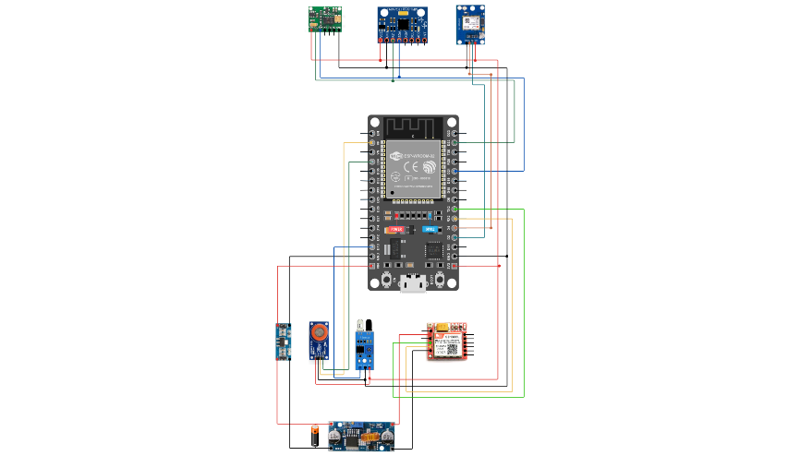
FLOW CHART DIAGRAM
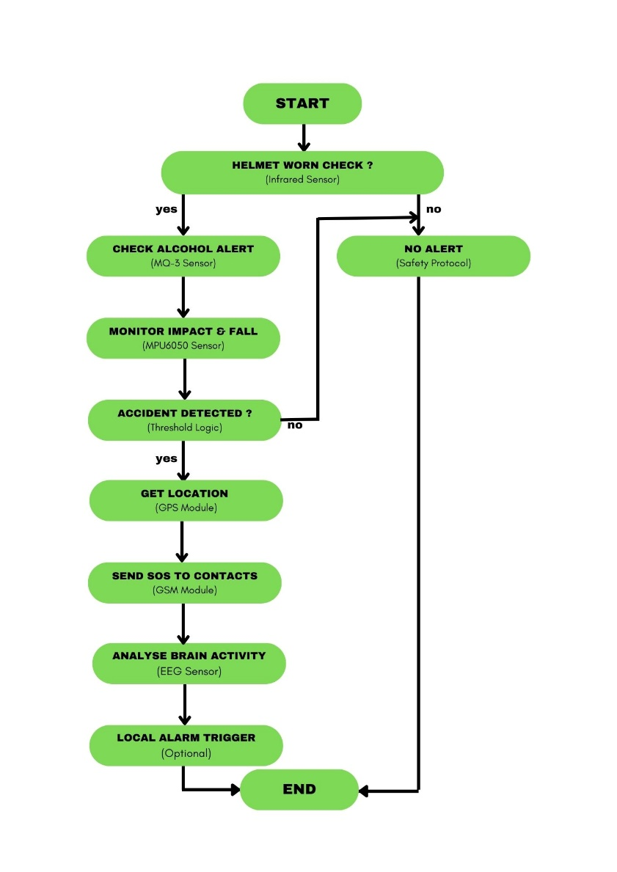

EXPLANATION OF FLOW CHART
1.Start:
- The system powers on and initializes all connected modules, including the sensors and communication units.
- It enters a continuous monitoring state to ensure the rider’s safety.
2. Helmet Worn Check (Infrared Sensor):
- The infrared sensor verifies whether the rider is wearing the helmet by detecting proximity.
- If the helmet is not worn, the system prevents the vehicle from starting and does not proceed to further checks.
3. Check Alcohol Alert (MQ-3 Sensor):
- The MQ-3 sensor measures the rider's breath for alcohol content.
- If alcohol levels exceed the preset threshold, the system disables the vehicle’s ignition and prevents the rider from operating it.
4. Monitor Impact & Fall (MPU6050 Sensor):
- The MPU6050 accelerometer and gyroscope monitor the helmet’s movement in real-time.
- It detects sudden impacts, free falls, or abnormal tilts, which may indicate an accident.
5. Accident Detected? (Threshold Logic):
- If the MPU6050 sensor records acceleration or tilt values exceeding the predefined threshold, the system classifies the event as an accident.
- Otherwise, normal monitoring continues without triggering an alert.
6. Get Location (GPS Module):
- Upon accident detection, the GPS module captures the rider’s real-time geographic coordinates.
- These coordinates are essential for emergency response and are included in the alert message.
7. Send SOS to Contacts (GSM Module):
- The GSM module sends an SOS message to pre-configured emergency contacts, including the rider’s current location.
- This alert ensures rapid assistance in case of an accident.
8. Analyze Brain Activity (EEG Sensor – Optional):
- The EEG sensor monitors brain wave patterns to detect anomalies like unconsciousness or seizures.
- If abnormal brain activity is detected, an additional alert can be triggered for further assistance.
9. Local Alarm Trigger (Optional):
- An optional buzzer activates locally to alert nearby individuals if an accident is detected.
- This feature helps by immediately drawing attention to the incident location.
10. End:
- After completing all checks and sending necessary alerts, the system either resets for continuous monitoring or remains in a standby mode.
- If no abnormal conditions are found, the system allows normal operation without interruptions.
TESTING AND RESULTS
Crash Detection: The MPU6050 sensor successfully detected impact events and triggered emergency alerts.
Alcohol Detection: The MQ-3 sensor reliably identified alcohol levels above 0.02% BAC, disabling vehicle ignition.
Emergency Notification System: The GSM module sent SOS messages within 5-10 seconds, ensuring rapid assistance.
Helmet Compliance Verification: The infrared sensor effectively enforced helmet usage before ignition activation.
SIMULATING RESULTS

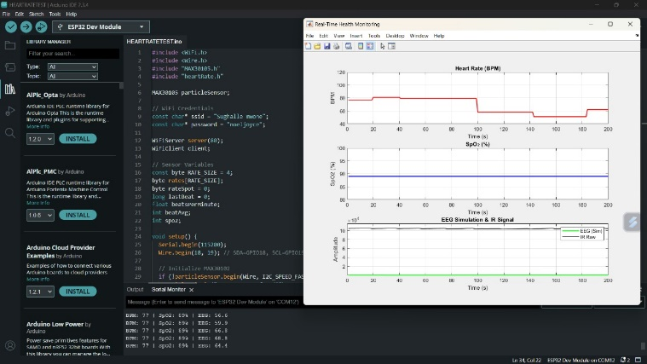

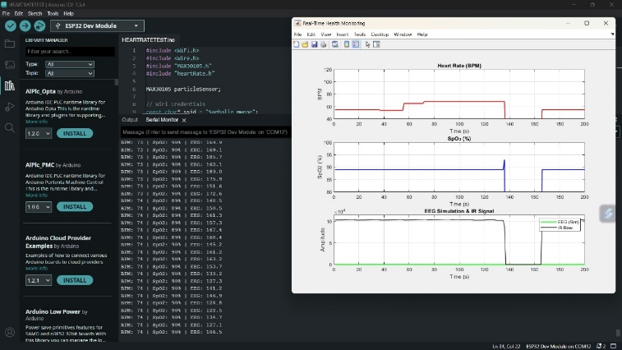

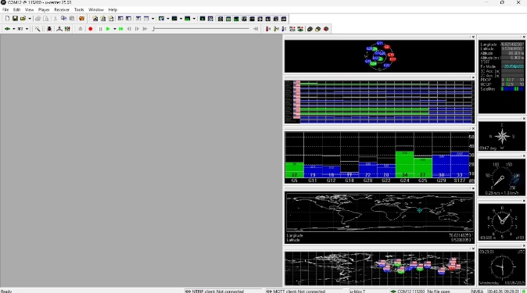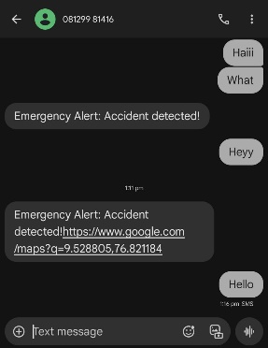
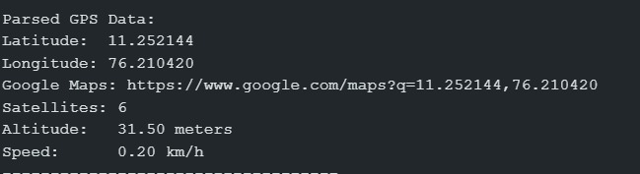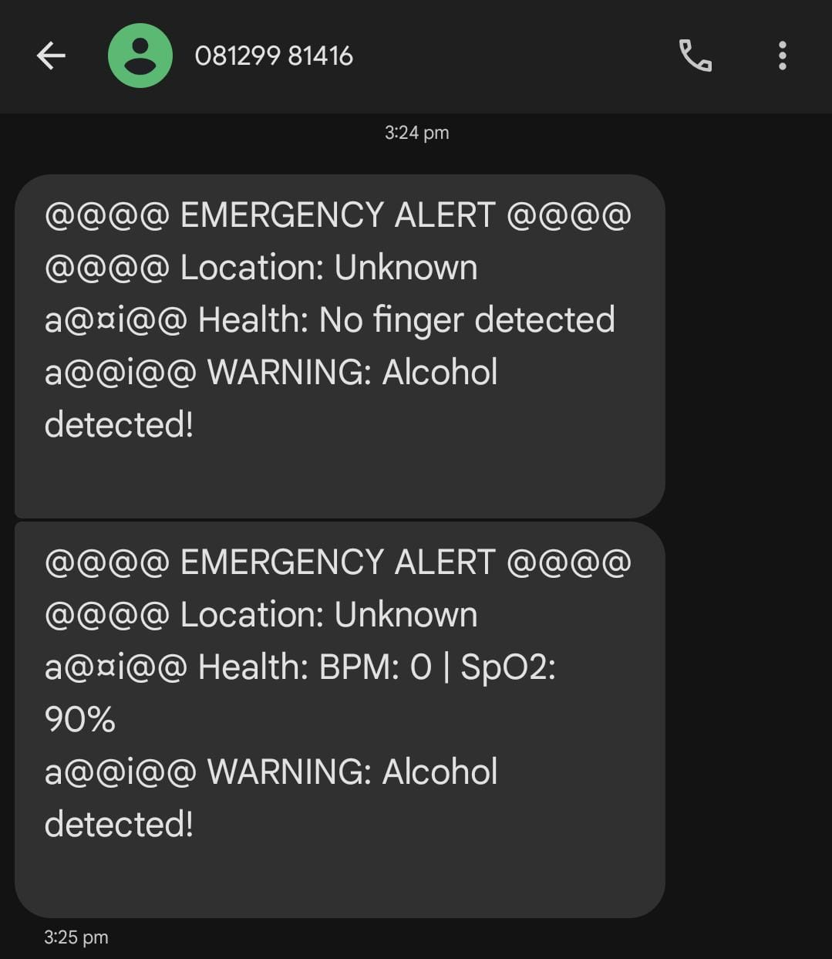
EQUATIONS
1.The resultant acceleration​ is calculated to detect sudden impacts or falls:
Resultant acceleration = a_{x} ²+a_{y}²+a_{z}²
Where:
- a_{x}, a_{y} , a_{z} are the acceleration components in x,y,z axes (m/s²)
2.The blood alcohol concentration (BAC) is derived from the output voltage of the MQ-3 alcohol sensor:
BAC = (V_{ref​ /}V_{out}​​) ×Calibration Factor
Where:
- V_{out} = Output voltage of the MQ-3 sensor (in volts).
- V_{ref}​ = Reference voltage (typically 5V).
- Calibration Factor = Sensor-specific constant (determined through calibration).
3. Distance Calculation (Infrared Sensor for Helmet Compliance):
d=K×(1/V_{out}​)
Where:
- d = Measured distance (in cm).
- V_{out}​ = Output voltage from the infrared sensor.
- K = Sensor-specific calibration constant.

CONCLUSION
  - The smart helmet system, utilizing the ESP32 microcontroller, MPU6050 sensor, MQ-3 alcohol sensor, GPS module, GSM module, and infrared sensor, demonstrated reliable performance in accident detection, alcohol monitoring, and emergency alerting. The system effectively detected impacts, monitored alcohol levels, and ensured helmet compliance, providing a comprehensive safety mechanism for motorcycle riders.
  - During the test, the system efficiently identified accidents in specified ranges and sent SOS alerts to emergency numbers in 5-10 seconds. The module for detecting alcohol properly recognized the level of drunkenness greater than 0.02% BAC and did not allow car ignition and minimised the incidence of driving while drunk. The infrared sensor strictly applied helmet enforcement by inhibiting ignition in the absence of the helmet.
Though the system demonstrated strong performance, there is room for further enhancement in terms of increasing sensor accuracy, eliminating false positives, and enhancing environmental resilience. Enhancement in the future will involve incorporating advanced algorithms to increase the accuracy of accident detection and using cloud storage to enable real-time monitoring and analysis. Integration with artificial intelligence models, like deep learning frameworks, might enhance accident forecasting as well as discern minor and heavy impacts.
Additionally, optimizing the SOS message system with instant voice notification and optimizing battery consumption will enhance usability and reliability in the system. Such developments would enhance the functionality of the smart helmet system as a better-in-time provider, encouraging safe riding practices, and maintaining rider security across diverse ambient conditions.
REFERENCE
[1] “Microcontroller based Smart Helmet using GSM & GPRS”.
Author(s): Prashant Ahuja, Ketan Bhavsar
[2] "Smart Helmet for Vehicles using IoT for Accident Avoidance".
Author(s): S. Prasad, R. Rajesh, and P. Kumar
[3] "Accident and Alcohol Detection Using AI-Enabled Smart Helmet"
Author(s): P. Tapadar and K. Ray

[4] " Internet of Things-Based Smart Helmet with Accident Identification"
Author(s): J. Kim, Y. Choi, and S. Lee

[5] Smart Helmet Using GSM &GPS Technology for Accident Detection and Reporting System
Authors: Manjesh N, Prof. Sudarshan Raj
[6] Smart Helmet with User Navigation Guidance Support
Author(s): Archana Bhamare, Swati Jagtap, Om Bhore, Pranav Pedhekar, Vaibhav Atharale
[7] "Fall Detection of Riders using Inertial Sensors: A Smart Helmet,"
Author(s): B. Kavya, A.V. Sai Yaswanth, M. Himaja, K.S.V. Abhilash, and M. Suneel.
[8] "An IoT-Based Framework for Remote Fall Monitoring"
Author(s): Ayman Al-Kababji, Abbes Amira, Faycal Bensaali, Abdulah Jarouf
https://www.semanticscholar.org/

https://www.researchgate.net/

https://www.sci-hub.st/

https://scholar.google.com/

https://www.arduino.cc/

https://chatgpt.com/

